**Information System Management Lab**

**BCOM 307**

**Assignment #29**

***Submitted by:***

**Name:** YASH JAIN

**Enrollment No:** 03914788818

**Semester:** B.Com(H) 5TH Semester

**Class:** B.COM(H)

**Section:** B.Com 5A

**Date of Submission:** 26/11/2021

***Submitted to:***

**Praveen Kumar Singh**

**Assistant Professor, MAIMS**



**Department of Commerce**

**Maharaja Agrasen Institute of Management Studies**

**Affiliated to Guru Gobind Singh Indraprastha University, Delhi**

**Sector -22, Rohini, Delhi -110086, India; www.maims.ac.in**

Maharaja Agrasen Institute of Management Studies

Affiliated to GGS IP University; Recognized u/s 2(f) of UGC Recognized by Bar Council of India; ISO 9001: 2015

Certified Institution Sector 22, Rohini, Delhi -110086, India; [www.maims.ac.in](http://www.maims.ac.in/)

Department of Commerce

Academic Year: 2020-21

Semester: Vth

# Assignment No. 29

# Unit No:

**Course/Subject Code:** BCOM 307 **Subject Title: Information System Management Lab**

# Issue Date Last Date of Submission:

**Instructions for Students:**

# All Questions are Compulsory.

1. The student should attach proper cover page for each assignment clearly mentioning the Assignment No.
2. Each assignment should be prepared by the student individually with proper explaination and screenshots.
3. A4 size ruled sheets should be used for the assignment.
4. Assignment pages should be serially numbered at the bottom of page.

***During online education mode, upload scanned copy of the complete assignment including cover page latest by due date.***

|  |  |  |
| --- | --- | --- |
| **Question No.** | **Question** | **CO No.** |
| 1 | Draw an ER diagram for an Educational Institute and convert it into a relational table. | C**CO1, CO2, CO6** |

**ASSIGNMENT 29 - ER Diagram to Relational Model**

**Task 1 : Draw an ER diagram for an Educational Institute and convert it into a relational table.**

This task can be completed using the **CREATE TABLE** Command. First, we need to make the ER Diagram.

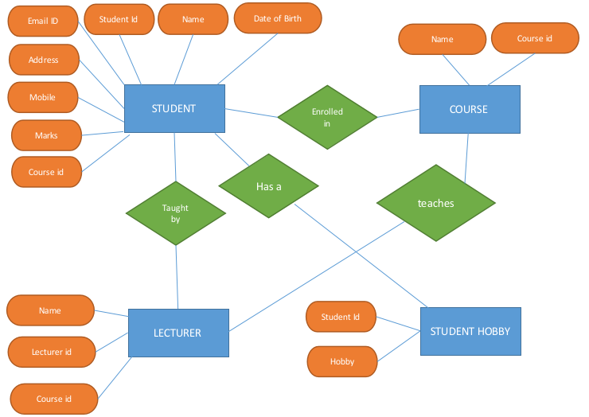

This diagram would enable us to make a relational model of the database, which looks like the one below :

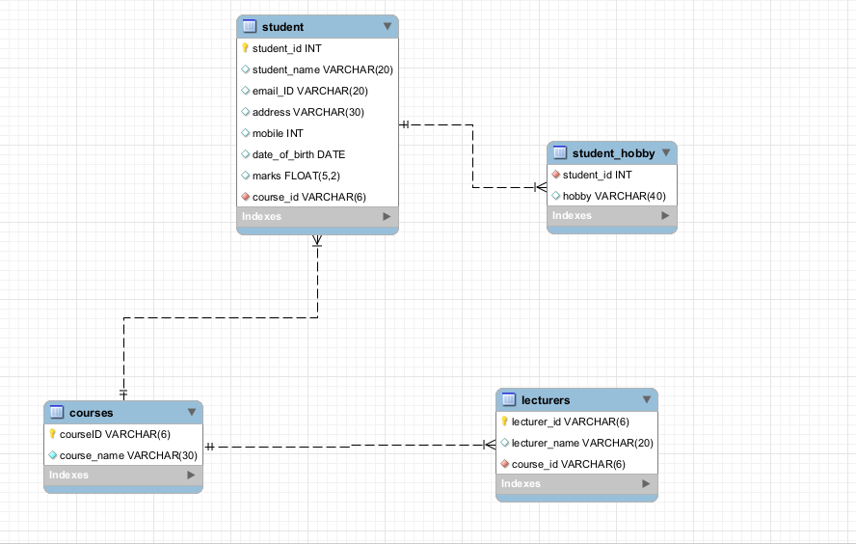

Now, the final step is to create the tables in MySQL as per the given relational model. This is where the **CREATE TABLE** Command is used.

Since there are multiple foreign key constraints to be applied to multiple tables, we first create all the foreign tables, and then the primary tables.

